

Syrian Private University
Faculty of artificial intelligence engineering Department of Robot engineering and intelligent

خط انتاج لتعبئة العطور
Perfume packaging production line

A quarterly project report that updated the requirements for obtaining a bachelor's degree in artificial intelligence engineering-robot engineering and intelligent systems

إعداد الطالب
محمد أنس غياث فاكهاني

إشراف
د. سامر حسام الدين
م.شادي صعب

2025-2026

SUPERVISOR CERTIFICATION

I Certify that the Preparation of this Project entitled by
…………………………………………………………………………………
, prepared by ………………………………………………………………...…
…………………………………………………………………………………
……………………………………………………………., was made under my supervision at Department of Robot engineering and intelligent in partial fulfillment of the Requirements for the Degree of Bachelors of Artificial intelligence engineering-robot engineering and intelligent systems

Name: ………………… Signature: Date:

Abstract

Manual bottle filling in small-scale industries suffers from spillage, inconsistent fill volumes, slow operation, and high labor dependency. This project presents the design and development of a low-cost, fully automated bottle filling system controlled by an Arduino mega microcontroller. The system integrates an HC-SR04 ultrasonic sensor for non-contact bottle detection at the filling station, a YF-S201 flow sensor for real-time volumetric measurement of the dispensed liquid, a stepper motor driving a chain conveyor for precise bottle positioning, and a solenoid valve actuated through a relay to control liquid flow. A Nextion 3.5-inch HMI provides a user-friendly interface for entering the target fill volume, monitoring system status, and visualizing real-time and historical filling data through graphical charts. Unlike timer-based filling systems, the proposed design uses closed-loop volumetric feedback from the flow sensor, ensuring accurate and repeatable fill quantities regardless of pressure variations. The system operates as follows: the user enters the desired volume via the HMI, the stepper motor advances the conveyor until the ultrasonic sensor detects a bottle, the valve opens, and the Arduino counts flow-sensor pulses until the target volume is reached, after which the valve closes and the conveyor resumes, with a total system cost significantly lower than commercially available filling machines. The modular and portable design makes the system suitable for small beverage, water, and chemical bottling industries, and it can be easily adapted to different bottle sizes and volumes through software configuration only.
Keywords: Automated bottle filling, Arduino mega, ultrasonic sensor, flow sensor, stepper motor, Nextion HMI, solenoid valve, volumetric control.
.

الملخص

تعاني عمليات تعبئة القوارير اليدوية في الصناعات الصغيرة من الانسكاب، وعدم ثبات الكميات المعبأة، وبطء الإنتاج، والاعتماد الكبير على العمالة. يقدّم هذا المشروع تصميماً وتطويراً لنظام تعبئة قوارير أوتوماتيكي منخفض التكلفة يعتمد على متحكم اردوينو ميغا. يدمج النظام حساساً فوق صوتياً لكشف القارورة دون تلامس في محطة التعبئة، وحساس تدفق لقياس الحجم الفعلي للسائل المتدفق لحظياً، ومحركاً خطوياً ستيبر يقود سيراً ناقلاً من نوع السلسلة لتحديد موضع القارورة بدقة، وصماماً كهربائياً يُشغَّل عبر مرحّل للتحكم بتدفق السائل. وتوفّر شاشة نيكسشن بمقاس 3.5 بوصة واجهة استخدام سهلة لإدخال الحجم المطلوب، ومراقبة حالة النظام، وعرض البيانات اللحظية والتاريخية عبر رسوم بيانية. وخلافاً لأنظمة التعبئة المعتمدة على الزمن، يعتمد التصميم المقترح على تغذية راجعة حجمية مغلقة من حساس التدفق، مما يضمن دقة تكرار الكميات المعبأة بغض النظر عن تغيّر الضغط. وتسير عملية التشغيل كما يلي: يُدخل المستخدم الحجم المطلوب عبر الشاشة، فيحرّك المحرك الخطوي السير حتى يكشف الحساس الفوق صوتي وجود القارورة، ثم يُفتح الصمام ويبدأ اردوينو بعدّ نبضات حساس التدفق حتى بلوغ الحجم المستهدف، فيُغلق الصمام ويستأنف السير حركته ، وبتكلفة إجمالية أقل بكثير من آلات التعبئة التجارية. ويجعل التصميم المعياري والمحمول النظام مناسباً لصناعات المشروبات والمياه والكيماويات الصغيرة..
الكلمات المفتاحية: تعبئة أوتوماتيكية، ، حساس فوق صوتي، حساس تدفق، محرك خطوي، شاشة، صمام كهربائي، تحكم حجمي.

Contents
Abstract ……….……………………………………………………….……...................II
III ................................................................................................................................. الملخص
Index of Figure ................................................................................................................. IV
Index of Table ................................................................................................................. IIV
Chapter1: Introduction ....................................................................................................... 2
1.1. Overview: .............................................................................................................. 3
1.2. Problem Statement: ............................................................................................... 3
1.3. Project Objectives: ................................................................................................ 3
1.4. Basic Definitions: .................................................................................................. 3
1.5. Project scope: ........................................................................................................ 4
1.6. Methodology: ........................................................................................................ 4
1.7. Report structure: .................................................................................................... 4
1.8. Conclusion............................................................................................................. 5 Chapter 2: Literature review .............................................................................................. 6
2.1. Literature preview: ......................................................................................................... 7
2.2. Analysis of previous studies........................................................................................... 8
2.3. Research gap .................................................................................................................. 9
2.4. Theoretical frame ......................................................................................................... 10 Chapter 3: Working environment ..................................................................................... 24
4.1. System Architecture and Design: ................................................................................. 25
3.2. Mathematical model: .................................................................................................... 26
Chapter 4: Quantitative Results Analysis ......................................................................... 34
Fifth chapter: Conclusion ................................................................................................. 37
References: ....................................................................................................................... 39

Index of Figure

FIGURE 1: MICROCONTROLLER AND ITS TYPES …………………………………….12
FIGURE 2: ULTRASOUND PROPAGATION …………………………………………….14
FIGURE 3: ARDUINO UNO ………………………………………………………………….17
FIGURE 4: HC-SR04 ULTRASONIC ………………………………………………………..18
FIGURE 5: TWO-CHANNEL RELAY MODULE …………………………………………..19
FIGURE 6: PUMP …………………………………………………………………………….19
FIGURE 7: BREADBOARD & WIRES ……………………………………………………...20
FIGURE 8: POWER SUPPLY ………………………………………………………………..21
FIGURE 9: A4988 Motor Driver…………………….. ………………………………...…….21
FIGURE 10: Limit Switch Sensor ………………………………….………………………...22
FIGURE 11: SYSTEM ARCHITECTURE DIAGRAM ..........................................................25
FIGURE 12: CIRCUIT CONNECTION MATRIX …………………………………………..27
FIGURE 13: SOFTWARE CONTROL FLOW DIAGRAM ………………………………….28
FIGURE 14: COMPONENT INTERACTION SEQUENCE DIAGRAM ……………………30
FIGURE 15: POWER DISTRIBUTION AND SAFETY DIAGRAM ……………………….31
FIGURE 16: STATE MACHINE DIAGRAM ………………………………………………..32
FIGURE 17: schematic diagrame………………………………………. ……………………33

VI

Index of Table
TABLE1: Comparison between existing research models and the proposed Arduino-Ultrasonic architecture………………………………..……………………………………………………9
TABLE 2: TECHNICAL RESULTS TABLE ………………………………………………..39
TABLE 3: COMPARISON TABLE WITH PREVIOUS STUDIES ………………………….40

Chapter1: Introduction
1.1. Overview:

The Automated Bottle Filling System is a low-cost, microcontroller-based solution for small-scale bottling industries. It eliminates manual filling problems such as spillage, inconsistent volumes, and slow production.
The system uses an Arduino mega microcontroller to coordinate all operations. An HC-SR04 ultrasonic sensor detects bottles without contact, while a YF-S401/YF-S201 flow sensor measures the dispensed volume in real time through digital pulses, enabling accurate closed-loop volumetric control. A stepper motor drives a chain conveyor for precise bottle positioning, and a solenoid valve (via relay) controls liquid flow from the reservoir.
A Nextion 3.5-inch HMI allows the user to enter the target volume, start/stop the process, and view real-time data and graphical charts.

1.2. Problem Statement:

Manual bottle filling in small-scale industries suffers from several critical shortcomings: liquid spillage during filling, inconsistent volumes from one bottle to another, slow operation due to human limitations, and high dependency on labor. These issues lead to product waste, customer dissatisfaction, and non-compliance with declared fill volumes.

1.3. Project Objectives:

The main objectives of this project are:
- To design and develop a low-cost automated bottle filling system suitable for small-scale industries
- To achieve accurate and repeatable fill volumes
- to provide a user-friendly touch interface via a Nextion HMI that allows the operator to set the target fill volume, start/stop the process
- Reduce operational costs and labor dependence.
- To visualize filling data graphically by displaying actual versus target volumes

  - Conclusion
This chapter provides a general introduction outlining the overall framework of the study, including a review of the research problem, its objectives and importance, as well as the scope of the study and its methodology.

  - proposed solution
The proposed solution is a low-cost, fully automated bottle filling system controlled by an ESP32 microcontroller. The system replaces manual filling with an integrated sequence of sensing, actuation, and user interaction:
· An HC-SR04 ultrasonic sensor detects the presence of a bottle at the filling station without contact.
· A YF-S401/YF-S201 flow sensor measures the dispensed liquid in real time by generating digital pulses proportional to volume, enabling closed-loop volumetric control instead of timer-based filling.
· A stepper motor drives a chain conveyor to position bottles precisely under the nozzle.
· A solenoid valve, actuated through a relay, opens and closes the liquid flow from the reservoir.
· A Nextion 3.5-inch HMI allows the user to enter the target fill volume, start/stop the process, and view real-time data and graphical charts.

Chapter 2: Literature review

This chapter establishes the academic foundation for the automated perfume filling system. It reviews the core technological frameworks of industrial automation, evaluates sensor and fluid dynamics literature, provides a critical analysis of previous studies, presents a comparative matrix of existing systems, and isolates the specific research gap this project addresses.
The last part of this chapter presents the theoretical frame of this project, by presenting micro controllers, sensors and actuators that are mainly used in filling automation process.
2.1. Literature preview:
The automation of liquid filling systems has been a subject of extensive research due to its industrial significance. Several researchers have explored different approaches to enhance dosing accuracy and system reliability:
➢ Automatic Bottle Filling System Using Arduino
1. Objective and Motivation
The primary goal of this project is to design and implement a low-cost, automated liquid filling system for small and medium-scale industries (such as soft drink and medicine manufacturing). Traditional automated machines are often prohibitively expensive for small businesses, forcing them to rely on manual labor. This project addresses that gap by utilizing an Arduino Mega 2560 microcontroller to create an efficient, robust, and economically friendly alternative that minimizes human intervention and errors.
2. System Architecture and Components
The system is built around an Arduino Mega 2560 board, which serves as the central processing unit. The hardware configuration includes:
· Sensors: An Infrared (IR) transmitter and receiver pair are used to detect the presence and position of bottles on the conveyor. The IR sensor acts as an external interrupt, sending a signal to the microcontroller when the light beam is blocked by a bottle.
· Actuators: Two DC motors (12V, 30 rpm) are employed. Motor 1 drives the conveyor belt (moving tray), while Motor 2 powers the filling mechanism (rotary pump).
· Control and Interface: The system uses a 2-line, 16-character LCD display for user interaction (e.g., "PRESS START", "START FILLING"). Relay circuits (controlled via ULN2003) are used to interface the low-power Arduino signals with the higher-power motors and solenoid valves.
· Power Supply: A dual-transformer power supply is utilized to step down 230V AC to 18V AC, which is then rectified and filtered to provide separate operating voltages for the microcontroller and the relays, preventing overload.
3. Working Principle
The operation is fully automated through a sequential control loop:
1. Upon powering on, the LCD prompts the user to press the start button.
2. The conveyor belt (Motor 1) moves until a bottle interrupts the IR beam.
3. The microcontroller stops Motor 1, positioning the bottle directly under the filling nozzle.
4. The microcontroller activates Motor 2 (the pump) for a pre-calculated time duration (based on the user-defined volume) to dispense the liquid.
5. Once the time delay elapses, the pump stops, and the conveyor belt restarts to bring the next bottle into position.
6. This process repeats for the entire batch.
4. Key Findings and Limitations
The study confirms that the automated system successfully reduces work, time, and cost compared to manual filling. The fabricated model is accurate enough for applications where high precision is not critical. However, the authors note that the system is application-specific; it may slow down production time and reduce machine capability compared to high-end industrial fillers. Therefore, it is recommended for small-scale operations rather than high-speed, precision-demanding environments.
5. Conclusion
The project demonstrates that integrating an Arduino board with a mechanical conveyor and IR sensors can effectively automate the bottle filling process. By replacing expensive industrial controllers with a widely available microcontroller, the system significantly lowers the barrier to entry for small-scale industries, allowing them to diversify and improve their operational efficiency.

Automated Bottle Filling and Capping Plant (Pandey et al., 2025)
Citation:
Pandey, G., Pokhrel, B., Budhathoki, S., & Mandal, S. K. (2025). Automated Bottle Filling and Capping Plant. Honeynexus, 2024. Kantipur Engineering College, Tribhuvan University, Nepal.
---
1. Objective and Motivation
The study addresses the limitations of manual and semi-automated bottling processes—namely labor intensity, inconsistent fill levels, spillage, and uncapped bottles—which increase waste and operating costs. The authors aim to develop a low-cost, Industry 4.0-compliant prototype that integrates computer vision with embedded control to perform inline filling, capping, and quality inspection of carbonated liquids.
2. System Architecture
The prototype is built around a Raspberry Pi 4 (vision processing) and an Arduino UNO (real-time control), communicating via UART.
· Conveyor & Star-Wheel: Bottles are transported on a conveyor and indexed through a six-slot rotating station disc driven by a NEMA 17 stepper motor.
· Station 1 – Filling: A 12 V DC pump dispenses 250 mL, timed by the Arduino.
· Station 2 – Capping: A dual-servo (MG996R) mechanism aligns and tightens plastic caps.
· Station 3 – Inspection/Dispatch: Two USB webcams (1080p, 30 FPS) capture images for fill-level and cap-presence verification under controlled LED lighting.
· Sensors: IR proximity sensors and limit switches synchronize bottle position.
3. Vision Algorithms
Two algorithms run on the Raspberry Pi:
1. Canny Edge Detection – Identifies the liquid meniscus boundary.
2. Distance Calculation – Compares the detected liquid level against a predefined reference line (datum) to classify bottles as Underfilled, FilledOK, or Overfilled. Cap presence is verified via color thresholding and contour analysis.
Control Logic (Finite State Machine):
· Underfilled bottles are automatically rotated back for refilling.
· Overfilled bottles are diverted to a reject chute.
· Uncapped bottles trigger up to two capping retries before rejection.
· All data (fill volumes, cap status, rejects) is logged to an MQTT-based IoT dashboard.
4. Key Results
Testing was performed on 250 mL PET bottles with carbonated dark liquid (100 bottles per trial, averaged over five runs).
Metric Manual Method Automated System
Cycle time/bottle ~20 s ~14 s
Throughput ~180 bottles/h ~257 bottles/h (+30%)
Fill accuracy (±2%) ~90% ~97%
Underfill/spillage rate ~10% ~3%
Reject rate ~12% ~5%
· Fill-level detection accuracy: 97%
· Cap detection accuracy: ~100% classification in tests
· Total hardware cost: ~45,000 NRs (≈ US$340)

Table1: Comparison between existing research models and the proposed Arduino-Ultrasonic architecture.
Aspect | Automated bottle filling and capping plant 2025 | Automatic bottle filling system using Arduino 2022
Main controller | Raspberry PI 4 + Arduino uno | Arduino mega 2560
sensors | IR + limit switches+ 2 usb webcams | IR sensor only
Detection technology | Image processing | Through IR
Fill-level inspection | 97% accuracy | Timer- based dispensing only
capping | yes | no
Automatic correction | yes | no
Motion mechanism | Conveyor belt + six slot star wheel disc driven by nema 17 stepper | Flat belt conveyor + 4 dc motors
Pump | 12v dc pump | Rotary pump + solenoid valve
User interface | IOT dashboard | Lcd display + push buttons
cost | 340usd | Very low

2.3. Research gap
Despite extensive research into automated liquid filling, a specific Research Gap exists in the optimization of low-cost, small-scale automation for volatile, high-value, and optically challenging fluids like perfumes.
Most current open-source systems use cheap IR sensors, which fail completely when encountering transparent glass or highly reflective metallic perfume bottles. Conversely, while industrial setups solve this with expensive laser or ultrasonic arrays, no standardized, open-source framework exists that optimizes a basic Arduino, an HCSR04 ultrasonic sensor, and a timed DC pump to combat the unique challenges of perfume manufacturing.
Specifically, existing literature fails to address:
- Volatile Fluid Evaporation and Viscosity Changes: Perfumes contain high concentrations of alcohol, which changes fluid dynamics and pump flow rates as temperatures fluctuate.
- Acoustic Reflection on Curved Surfaces: Standard perfume bottles feature highly stylized, non-cylindrical, or curved glass shapes that scatter ultrasonic waves, a phenomenon poorly documented in standard flat-surface sensor tests.
This project bridges this gap by creating an affordable, open-source engineering blueprint that uses custom software filters to stabilize ultrasonic readings on irregular bottle shapes, offering high-precision volumetric filling without industrial-grade costs. Despite extensive documentation on automated liquid packaging, a distinct Research Gap exists in the optimization of low-cost, microcontroller-driven automation frameworks tailored specifically for volatile, geometrically irregular, and optically challenging containers.
Specifically, the literature fails to reconcile three intersecting design criteria:
- Acoustic Scattering on Complex Glass Geometries: There is a lack of standardized, open-source software algorithms (such as moving-average filters or ultrasonic median filtering) designed to stabilize HC-SR04 distance readouts when targeting curved, faceted perfume bottles.
- Volumetric Drift in Low-Cost Timed Systems: No open-source engineering blueprint addresses how to counter pump flow-rate drift caused by voltage drops and fluid temperature variations without introducing expensive, clog-prone physical flow meters.
- Hazardous Fluid Integration on Open Platforms: The literature lacks simplified safety protocols for isolating sparking electromechanical relays and brushed DC pump motors from volatile perfume vapors within a low-budget framework.
This project directly bridges this research gap by developing a scalable, cost-effective engineering model that uses an Arduino and an ultrasonic sensor, combined with targeted software filters, to reliably process highly stylized transparent glass containers while maintaining safe fluid dispensing.
2.4. Theoretical review

The transition from manual labor to fully integrated automated systems represent a pivotal shift in modern industrial engineering. This chapter establishes the theoretical foundation necessary to understand the synergy between micro-embedded systems and sensory perception in the context of fluid dynamics. At the core of an automated perfume packaging line lies the integration of real-time object detection and precise mechanical actuation.
To achieve the project’s overarching goal of a "contactless user experience," it is essential to explore the physics of ultrasonic wave propagation and the logic of digital relay switching. Unlike traditional mechanical triggers, which are prone to wear and tear and lack the required hygiene standards for high-end fragrance packaging, the electronic components selected for this system—primarily the Arduino Mega and the HC-SR04 sensor—operate on the principle of non-invasive monitoring.
Furthermore, this framework delves into the significance of signal processing within the microcontroller, explaining how raw data from the environment is translated into timed electrical pulses that govern the pumping mechanism. By analyzing the technical specifications and operational theories of these components, we provide a rigorous justification for their selection, ensuring that the system not only meets the requirement of a 2-second infusion accuracy but also maintains a scalable architecture for future industrial deployment.

➢ Microcontroller System [11]:

A microcontroller (MC, uC, or μC) or microcontroller unit (MCU) is a small computer on a single integrated circuit. A microcontroller contains one or more processor cores along with memory and programmable input/output peripherals. Program memory in the form of NOR flash, OTP ROM, or ferroelectric RAM is also often included on the chip, as well as a small amount of RAM. Microcontrollers are designed for embedded applications, in contrast to the microprocessors used in personal computers or other general-purpose applications consisting of various discrete chips.
In modern terminology, a microcontroller is similar to, but less sophisticated than, a system on a chip (SoC). A SoC may include a microcontroller as one of its components but usually integrates it with advanced peripherals like a graphics processing unit (GPU), a Wi-Fi module, or one or more coprocessors.
Microcontrollers are used in automatically controlled products and devices, such as automobile engine control systems, implantable medical devices, remote controls, office machines, appliances, power tools, toys, and other embedded systems. By reducing the size and cost compared to a design that uses a separate microprocessor, memory, and input/output devices, microcontrollers make digital control of more devices and processes practical. Mixed-signal microcontrollers are common, integrating analog components needed to control non-digital electronic systems. In the context of the Internet of Things, microcontrollers are an economical and popular means of data collection, sensing and actuating the physical world as edge devices. Some microcontrollers may use four-bit words and operate at frequencies as low as 4 kHz for low power consumption (single-digit milliwatts or microwatts). They generally have the ability to retain functionality while waiting for an event such as a button press or other interrupt; power consumption while sleeping (with the CPU clock and most peripherals off) may be just nanowatts, making many of them well suited for long lasting battery applications. Other microcontrollers may serve performance-critical roles, where they may need to act more like a digital signal processor (DSP), with higher clock speeds and power consumption.
➢ Microcontroller Applications [11]:

Across an array of modern applications and industries, microcontrollers have quickly achieved widespread market penetration and can be found today in many technologies and gadgets. Any electronic device containing a sensor, a display, a user interface and a programmable output control or actuator is likely to feature an MCU.
Some of the more common microcontroller projects, functions, applications and environments where they are used include:
- Automation and robotics.
- Consumer electronics and domestic appliances.
- Medical and laboratory equipment (handheld diagnostic devices, scanners and X-ray machines, measuring, analysis and monitoring tools).
- Automotive industries and vehicle control systems (powertrain adjustment, multimedia consoles and navigation software).
- Industrial and production environment controls (heating and lighting, HVAC systems and safety locking mechanisms).
- IoT devices and systems.

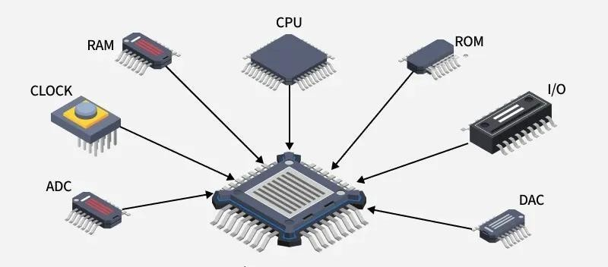

Figure 1: Microcontroller and its components

- Microcontroller components [12]:

Microcontrollers are small electronic devices that contain a CPU, memory, digital and analog inputs and outputs, and are used in controlling and converting digital signals to control various electronic devices. Microcontrollers consist of several main components, including:
  - Central Processing Unit: (CPU) the Central Processing Unit is the main brain of the microcontroller, executing programs stored in memory and converting digital signals to control electronic devices.
  - Memory: (Memory) microcontrollers have several types of memory, including Ram, programmable memory (ROM) and flash memory (Flash Memory) which is used to store programs and data.
  - Inputs and outputs :(I/O Ports) microcontrollers have digital and analog inputs and outputs, which are used to connect and control various electronic devices. The inputs can be used to read digital or analog signals from various devices, while the outputs can be used to send digital or analog signals to control devices.
  - Timers: (Timers) microcontrollers contain precise timers, which are used to generate the signals necessary to control various electronic devices. Timers can be used to generate pulse signals, timing, speed control and timing.
  - Analog - digital converters: (ADC) microcontrollers contain analog - digital converters, which are used to convert analog signals into digital signals, this helps in reading analog signals from various devices and converting them into digital signals to control devices.
  - Digital-analog converters: (DAC) microcontrollers contain digital - analog converters, which are used to convert digital signals into analog signals, and this helps in generating the analog signals necessary to control various devices.
With these key components, microcontrollers are a powerful and effective tool in digital control and transformation, used in multiple fields such as industry, medical, automotive, smartphones and other smart devices.
- Types of microcontrollers [13]:

Microcontrollers are compact electronic devices that are used to control various devices and systems. These controllers are characterized by their compact size and high integration, which makes them ideal for use in many different applications such as robotics, mobile devices, industrial control systems, automobiles, medical devices and home electronics, among others.
Many types of microcontrollers are available, differing in the processor used, memory, programmable recommendations and various interfaces. Here are some common types of microcontrollers:
  - Arduino: Arduino Development Boards are one of the most popular microcontrollers used in amateur and professional projects alike. They are distinguished by Ease of Use and the availability of many additional modules and sensors that can be used with them.
  - Raspberry Pi: although the Raspberry Pi is considered a full-fledged device for a smallsized computer, it also has a microcontroller built into the device. Raspberry Pi is characterized by the power of its processor and the possibility of running the Linux operating system.
  - PIC Microcontroller: PIC controllers from Microchip Technology are one of the popular types of microcontrollers. Available in various sizes and versions, they are characterized by Ease of programming and use, provide many features and interfaces.
  - AVR Microcontrollers: Atmel AVR controllers are also popular in the field of Electrical Engineering and electronics. It has high performance, low power consumption, provides many features and interfaces.
  - ARM Cortex-m: ARM Cortex-M controllers are one of the latest types used in microcontrollers. Characterized by processing power and providing many features and interfaces, they are widely used in industrial and portable applications
- Microcontrollers in Industrial Automation [14]:

Microcontrollers (MCUs) represent a fundamental component in modern industrial automation systems, where they provide compact, low-power, and real-time control for a wide range of applications, including machinery, robotic systems, and sensor networks. Acting as intelligent processing units, microcontrollers are capable of acquiring and processing analog and digital signals from sensors, executing high-speed control algorithms, and managing communication between different system components.
In industrial environments, microcontrollers play a critical role in process control by continuously monitoring key parameters such as temperature, pressure, and flow rates, thereby ensuring optimal system performance and efficiency. They are also extensively used in robotics and motion control applications, where precise timing and rapid processing are required to achieve accurate positioning and smooth operation of motors and actuators. Furthermore, with the emergence of the Industrial Internet of Things (IIoT), microcontrollers serve as edge devices that collect operational data, support predictive maintenance strategies, and facilitate data transmission to higher-level systems or cloud platforms.
From a technical perspective, industrial-grade microcontrollers are characterized by high reliability and robustness, enabling them to operate under harsh environmental conditions, including wide temperature ranges and high electrical noise. They typically integrate multiple components—such as the central processing unit (CPU), memory units, and peripherals like analog-to-digital converters (ADC), timers, and pulse-width modulation (PWM) modules— onto a single chip, which enhances efficiency and reduces system complexity. Additionally, modern microcontrollers often incorporate advanced security features to protect against potential cyber threats.
Several microcontroller families are widely adopted in industrial applications, including ARM Cortex-M series, Texas Instruments C2000, and Microchip PIC/AVR architectures. Compared to programmable logic controllers (PLCs), microcontrollers are generally more suitable for embedded and cost-sensitive applications that require customized control solutions, while PLCs are preferred for large-scale, modular industrial systems due to their robustness and ease of reconfiguration.
➢ Ultrasound sensors [15]:

Ultrasound is one of the modern technologies that are used in many fields, and this technique is used to detect objects and materials that cannot be seen with the naked eye, using sound waves whose frequencies range from 20 kHz to 1 GHz.
Ultrasonic waves are used in many fields, such as the aviation and aerospace industry, where they are used to detect any defect in the structure of an aircraft or spacecraft, and are also used in the shipbuilding industry to detect any crack or defect in the hull of a ship.
Ultrasound is also used in medicine, where it is used to detect tumors, cancerous tumors, fibroids, and is also used in surgical operations and medical diagnostics.
Ultrasound is also used in the food industry, where it is used to examine food and beverages to detect any impurities or undesirable substances, and is also used in the pharmaceutical industry to detect any defect in pharmaceutical products.
Ultrasonic waves are also used in the automotive industry, where they are used to detect any malfunctions in the bodywork of a car, and are also used in the electronics industry to detect any malfunctions in electronic circuits.
Ultrasound is an important technology that is used in many fields and contributes to improving the quality of products, services and healthcare, and thanks to the continuous technological development, it is expected that this technology will continue to improve and evolve to meet the needs of users.
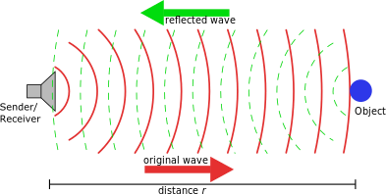

Figure 2: Ultrasound propagation
- Qualities of ultrasonic waves [16]:

Ultrasound is one of the modern types of waves that are used in many fields, as it has unique qualities that make it useful and effective in detecting objects and substances that cannot be seen with the naked eye. Below we will talk about some of the qualities of ultrasound:
  - High Frequency: Ultrasonic waves are characterized by their high frequency, ranging from 20kHz to 1GHz, which makes them able to penetrate objects and materials easily.
  - Reflection: ultrasonic waves are characterized by their ability to reflect off the objects and materials they hit, allowing the receiver to analyze these signals and convert them into a three-dimensional image.
  - Safety: ultrasound is one of the safe and harmless techniques for the body, as it does not use any radiation rays, and does not leave any side effects on the body.
  - Precision: ultrasonic waves are characterized by their high accuracy in the analysis and detection of objects and materials, which makes them useful in many fields such as medicine, aviation, aerospace and ship industry.
  - Speed: ultrasound is characterized by its high speed in detecting objects and materials, as it can be used in medical diagnostics and tumor detection processes with high speed
and accuracy.
  - Control: ultrasound has the possibility of controlling the transmission intensity and frequency, which allows the user to adjust the device according to his needs and the requirements of the field in which it is used.
  - Sustainability: ultrasound is a sustainable technology, as it does not use any harmful substances or cause any side effects on the environment.
- The principle of action of ultrasound [17]:

In the process of transmitting sound waves, a device called a cracker or source is used, it transmits sound waves through air or liquid, and as soon as these waves reach the object to be examined, some of these waves are absorbed, while some return to the source device.
After that, a device called a receiver is used, it analyzes the sound signals that have been bounced off the object to be examined, and these signals are converted into a three-dimensional image, through which the object can be accurately seen.
The fundamental operation of an ultrasonic sensor, such as the HC-SR04, relies on the "Time of Flight" (ToF) principle. The device consists of a transducer that functions as both a transmitter and a receiver. The transmitter emits a sonic burst that travels through the air until it strikes a target (the perfume bottle). Upon impact, the wave is reflected back to the receiver. The distance is then calculated by the microcontroller using the relationship between the speed of sound in the atmosphere and the time interval between emission and reception, as expressed in the following equation:
Elapsed time×Speed of Sound Distance =
2
In this project, understanding the acoustic properties of the environment is crucial. Factors such as the beam angle and the surface material of the bottles can influence the accuracy of the reflected signal. By implementing digital filtering within the Arduino logic, the system can distinguish between a valid packaging unit and environmental noise, ensuring that the pump is only activated when a bottle is precisely positioned. This theoretical framework provides the basis for achieving the high-precision object detection required for a seamless and automated filling sequence.

- Electromechanical Switching and Relay Theory [18]:

In automated systems, interfacing low-voltage control circuits with high-power actuators requires a reliable isolation and switching mechanism. A relay is an electromechanical switch that fulfills this requirement by using electromagnetism to open or close electrical contacts. In this project, the relay module serves as the critical interface between the Arduino Uno (operating at 5V) and the liquid pump (operating at 5V), ensuring that the sensitive microcontroller is protected from high-current surges.

The fundamental principle of a relay involves an internal coil wound around an iron core. When a small electrical current from the Arduino energizes this coil, it creates a magnetic field that attracts a movable armature. This physical movement changes the state of the switch from "Normally Open" (NO) to "Closed," thereby completing the high-voltage circuit for the pump. One of the most vital theoretical aspects of relay integration is Galvanic Isolation. This principle ensures that there is no direct electrical path between the control logic and the power load. Furthermore, the use of a flyback diode within the module is essential to suppress "inductive spikes" or back-EMF, which occurs when the magnetic field in the pump’s motor collapses.
Understanding these electromagnetic interactions is essential for designing a stable production line that can withstand repetitive switching cycles without damaging the central processing unit.

- Galvanic Isolation and Circuit Protection [19]:

A fundamental theoretical advantage of using electromechanical relays in production lines is the achievement of Galvanic Isolation. This principle ensures that there is no direct conduction path between the low-power control unit (Arduino Uno) and the high-power load (5V Pump). By separating the control and load stages through a magnetic field rather than an electrical connection, the system effectively prevents transient voltages and heavy-current noise from reaching the microcontroller.
This isolation is critical for maintaining signal integrity and preventing "latch-up" or permanent damage to the ATmega328P chip during the repetitive switching cycles required for perfume filling. Furthermore, understanding the role of the relay’s isolation helps in designing a robust grounding strategy, ensuring that the power supply for the actuators does not interfere with the precision of the sensory data processed by the Arduino.
- Introduction to Arduino [20]:

Arduino is an open-source electronics platform based on flexible, easy-to-use hardware and software. It was designed to provide a low-cost and accessible way for engineers and designers to create interactive objects that can sense and control the physical world. The core philosophy of the Arduino ecosystem lies in its standardized pinout and the Arduino Integrated Development Environment (IDE), which uses a simplified version of C++ to manage complex micro-embedded tasks.
In industrial automation and prototyping, Arduino has become a fundamental tool due to its vast community support and extensive library of pre-written code for various sensors and actuators. It functions as a bridge between the physical environment and digital logic; it reads inputs—such as light on a sensor or a finger on a button—and turns them into outputs, like activating a motor or turning on an LED. This modularity makes it the most suitable controller for developing high-precision systems like the perfume packaging line, where reliability and rapid signal processing are essential for maintaining production efficiency.
- Features of Arduino:

Arduino is one of the most famous electronic boards used in the development of electronic devices, it has many features that make it a favorite among users.
  - Ease of use: Arduino is considered easy to use and learn, as anyone can learn it quickly and easily without the need for prior knowledge of programming or electronics.
  - Interoperability: The Arduino can be compatible with a wide range of different electronic components, which makes it ideal for the development of various electronic devices.
  - Large selection of libraries: Arduino has a huge selection of libraries that can be used to develop various electronic devices, which makes the programming process easier and faster.
  - Compatibility with many programming languages: Arduino can be compatible with many different programming languages such as C, C++ and Python, allowing users to use the language they feel comfortable using.
  - Open source: Arduino is considered open source, which means that users can access, modify and develop the source code according to their needs.
  - Easy delivery:The Arduino is characterized by Ease of connection, as users can easily and conveniently connect various electronic components.
  - Compatibility with different development environments: Arduino can be compatible with various development environments such as Arduino IDE, Visual Studio Code and others, allowing users to use the environment that they feel comfortable using.
  - Availability of open sources:The surrounding Urdu community provides many open sources available on the internet, which helps users to learn programming and develop electronic devices easily and conveniently.
In general, Arduino has many features that make it ideal for the development of various electronic devices, as it is characterized by Ease of use, learning, compatibility with a wide range of different electronic components, in addition to compatibility with many different programming languages and the availability of open sources
- Arduino Uno [21]:

It is the most famous Arduino board and has everything you need to get started and has 14 digital I / O ports (6 of which can be used as PWM outputs), 6 analog inputs, a USB connection, a power socket, a reset button and more.
Arduino Uno is one of the most famous types of Arduino development boards, it is characterized by Ease of Use and learning, it also supports many different electronic components, and comes with an internal memory of 32 KB. Key Specifications used: Operating Voltage: 5V.
Digital I/O Pins: 14 (used for Trigger, Echo, and Relay signal). Flash Memory: 32 KB (sufficient for the C++ control logic).
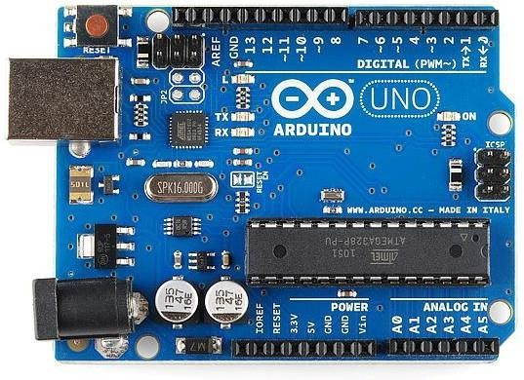

Figure 3: Arduino Uno ➢ Ultrasonic Sensor [22]:

The HC-SR04 is an affordable and easy to use distance measuring sensor which has a range from 2cm to 400cm (about an inch to 13 feet).
The sensor is composed of two ultrasonic transducers. One is transmitter which outputs ultrasonic sound pulses and the other is receiver which listens for reflected waves. It’s basically a SONAR which is used in submarines for detecting underwater objects.
It emits an ultrasound at 40 000 Hz which travels through the air and if there is an object or obstacle on its path It will bounce back to the module. Considering the travel time and the speed of the sound you can calculate the distance.
To achieve the contactless filling objective, the HC-SR04 module is integrated. In the work environment, this sensor is positioned at a fixed distance from the conveyor or bottle placement area.
Operational Range: 2cm – 400cm.
Accuracy: Up to 3mm, ensuring the pump only triggers when the bottle is perfectly aligned.
The sensor has 4 pins. VCC and GND go to 5V and GND pins on the Arduino, and the Trig and Echo go to any digital Arduino pin. Using the Trig pin, we send the ultrasound wave from the transmitter, and with the Echo pin we listen for the reflected signal.
In order to generate the ultrasound, we need to set the Trig pin on a High State for 10 µs. That will send out an 8-cycle ultrasonic burst which will travel at the speed of sound. The Echo pins goes high right away after that 8-cycle ultrasonic burst is sent, and it starts listening or waiting for that wave to be reflected from an object.
If there is no object or reflected pulse, the Echo pin will time-out after 38ms and get back to low state.
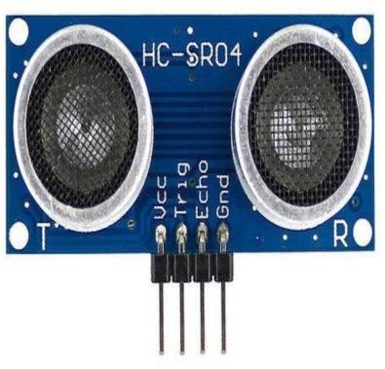

Figure 4: HC-SR04 Ultrasonic

➢ Relay Module and Pump:

A two-channel relay module is an electromechanical switch board that allows a low-power device, such as an Arduino or Raspberry Pi, to independently control two high-power electrical circuits. It serves as a bridge, enabling a 5V (or 3.3V) microcontroller to safely turn on or off devices like lamps, motors, or fans that operate on much higher voltages (up to 250VAC or 30VDC). [8]
The actuation stage of this system is responsible for the physical delivery of the liquid, translating digital logic into mechanical motion. This is achieved through a coordinated link between a Two-Channel Relay Module and a 5V DC Pump. The relay module acts as an electronically controlled switch, providing a crucial bridge between the Arduino Uno’s 5V signal and the 5V high-current requirement of the pump. In this setup, the "Normally Open" (NO) terminal is utilized to ensure that the pump remains inactive until the HC-SR04 sensor confirms the presence of a bottle, at which point the Arduino triggers the relay coil for a precise duration of 2 seconds.
This duration was calibrated during the work environment setup to match the pump’s flow rate with the required volume of the perfume unit.
The power management for this stage is equally critical. To prevent electrical noise and potential "brownouts" that could reset the microcontroller, the system employs a dual-rail power configuration. A 12V external power supply is dedicated to the pump, while the Arduino and the relay's control logic are powered via a regulated 5V source. This separation is vital for maintaining the stability of the inductive load generated by the pump’s motor. Furthermore, the relay module features an onboard opt isolator and a flyback diode, which serve to suppress backEMF spikes during the frequent switching cycles. This robust integration of power and actuation ensures that the system provides consistent dosing accuracy while maintaining longterm hardware reliability in a continuous production environment.
Two-Channel Relay Module: Used to bridge the 5V logic of the Arduino with the 5V requirement of the pump. Although it has two channels, only one is utilized for the primary pump control.
Submersible/Diaphragm Pump: A 5V DC pump capable of delivering the required perfume volume within the 2-second programmed window
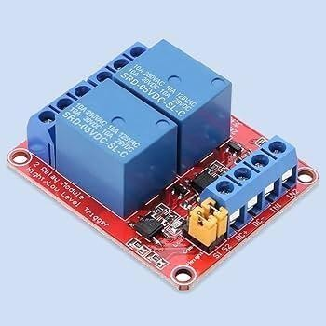

Figure 5: Two-channel Relay module

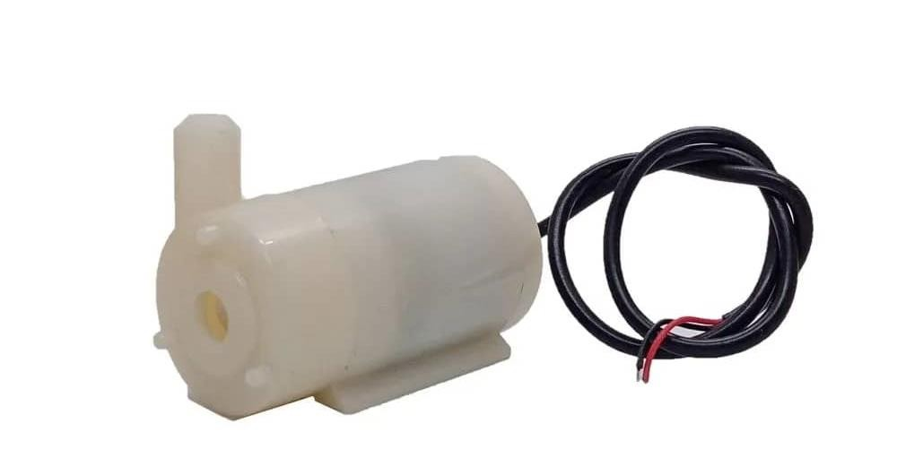

Figure 6: Pump

➢ Prototyping and Connectivity (Breadboard & Wires):

To facilitate a flexible and error-free development process, the system’s electrical architecture was established using a temporary prototyping interface rather than permanent soldering. This approach allowed for iterative testing and hardware debugging during the assembly phase of the perfume packaging line.
Solderless Breadboard: A standard 830-point breadboard was utilized to map the interconnections between the Arduino Uno and the peripheral modules. This board features a split-rail design for power distribution (VCC and GND), which was essential for providing a common ground between the 5V logic and the sensor's power pins. Its high-density contact points ensured stable connections for the HC-SR04 ultrasonic sensor, preventing signal jitter during distance measurements.
Jumper Wires: A combination of Male-to-Male (M-M) and Male-to-Female (M-F) jumper wires was employed to route the signals. M-F wires were specifically used to connect the header pins of the HC-SR04 sensor and the Relay module directly to the breadboard and the Arduino’s digital pins. These wires were color-coded (e.g., Red for VCC, Black for GND) to maintain a systematic wiring scheme, which is crucial for reducing the risk of short circuits and ensuring easy maintenance of the production line prototype.
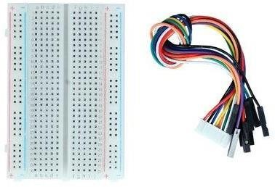

Figure 7: Breadboard & Wires

➢ Power Supply and Voltage Regulation Unit:

A robust power management strategy is the backbone of any automated system involving inductive loads. For this project, a dual-output power configuration was engineered to separate the sensitive logic components from the high-power mechanical actuators, thereby ensuring operational stability and preventing electrical interference.
12V DC Power Supply: A dedicated 12V external power source was integrated to drive the liquid pump. This high-voltage rail is switched via the relay module. By providing a separate supply for the pump, the system ensures that the sudden current draw (in-rush current) during the motor’s startup does not cause a voltage drop in the microcontroller's circuit, which could otherwise lead to system resets or erroneous sensor readings.
5V Logic Supply: The Arduino Uno and the control logic of the HC-SR04 sensor are powered via a stabilized 5V supply. This was achieved using the Arduino's onboard voltage regulator, which converts the input voltage to a clean 5V output. This "Logic-Power Separation" is a critical design choice in the work environment to eliminate electromagnetic noise (EMI) generated by the pump, ensuring that the distance detection remains precise and the 2-second infusion timing remains consistent throughout the production cycles.
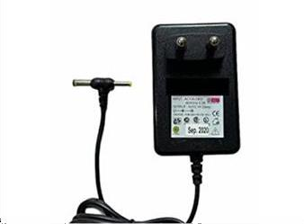

Figure 8: Power Supply

➢ A4988 motor driver
The A4988 is a complete, monolithic micro stepping motor driver IC featuring a built-in translator, manufactured by Allegro Micro Systems.
It is designed to operate bipolar stepper motors in full-, half-, quarter-, eighth-, and sixteenthstep modes, with an output drive capacity of up to 35 V and ±2 A.
Functional Architecture and Core Benefits:
- Standard stepper motor actuation typically requires complex phase-sequence generation via an external microcontroller. The A4988 simplifies this control architecture through its integrated translator:
- Two-Pin Interface: Actuation requires only a digital STEP pulse to advance the motor and a DIR state to dictate rotational direction.
- Microstepping Control: By adjusting three logic inputs (MS1, MS2, MS3), the driver utilizes internal digital-to-analog converters (DACs) to fractionalize current phases. This yields up to 1/16 microstepping, which significantly mitigates mechanical resonance, minimizes acoustic noise, and increases positional resolution.
- Automatic Current Decay: The IC features an internal current decay regulator that automatically selects between fast, slow, or mixed decay modes during Pulse Width Modulation (PWM) operation, optimizing torque smoothness.
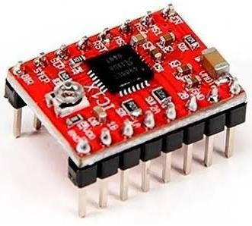

Figure 9- A4988 motor driver

Protection and Safety Systems: to ensure system robustness in experimental and industrial environments, the A4988 integrates several protective sub-circuits:
- Thermal Shutdown (TSD): Disables outputs if junction temperatures exceed safe thresholds.
- Undervoltage Lockout (UVLO): Prevents erratic operation during supply voltage drops.
- Crossover-Current Protection: Prevents shoot-through currents in the H-bridge MOSFETs.

➢ Limit switch sensor:
A limit switch is an electromechanical sensor that detects the physical presence, absence, or proximity of an object by establishing a direct mechanical contact. It converts mechanical motion into an electrical signal to regulate mechanical travel boundaries.
Limit switches are composed of an external actuator mechanism (such as a plunger, roller, or lever) mechanically linked to a set of internal electrical contacts:
- Contact Configurations: They feature Normally Open (NO) and Normally Closed (NC) terminals, providing versatility for circuit interruption or signal triggering. Passive Operation: Unlike inductive or optical proximity sensors, electromechanical limit switches require no electrical power to operate.
- Reliability: They offer precise repeatability, high current-carrying capacity, and high immunity to electrical noise (EMI) and environmental contamination (dust, moisture).

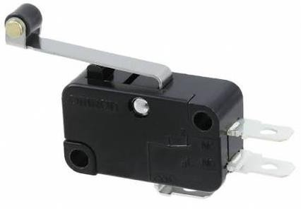

Figure10- Limit switch sensor

As a conclusion of this chapter a literature review has been done to show the previous researches have been made about the automation of liquids filling process in special perfume one. Review showed that there is a research gap in using passive contactless sensor with simple actuating unit, and that is the purpose of the suggested project.
Finally this chapter presented the theoretical parts of components that will be used in this project as microcontrollers, actuators and sensors.

23

Chapter 3: Working environment

This chapter delineates the proposed technical solution for the automated perfume packaging production line. The system is designed to automate the dispensing process based on object detection, ensuring precision, safety, and efficiency. The proposed architecture integrates a microcontroller unit, ultrasonic sensing technology, and electromechanical actuation controlled via a relay module. The solution addresses critical engineering constraints, particularly regarding power management and signal integrity, to ensure reliable operation within an industrial or prototype environment.
The proposed solution aims to transition from traditional, manual perfume filling which is prone to human error and hygiene issues—to a fully automated, sensor-driven system. This solution integrates real-time distance sensing with high-precision timed pumping, controlled by a central Arduino Uno unit. By utilizing non-contact ultrasonic technology, the system ensures a sterile environment and consistent dosing accuracy.
4.1. System Architecture and Design:

The proposed system operates on a closed-loop control mechanism where the presence of a perfume bottle is detected by an ultrasonic sensor. Upon verification of the object within a predefined range, the microcontroller triggers a dispensing pump via a relay module. The system architecture is divided into three primary subsystems: the Control Unit, the Sensing Unit, and the Actuation Unit.
The proposed architecture is divided into three functional layers:
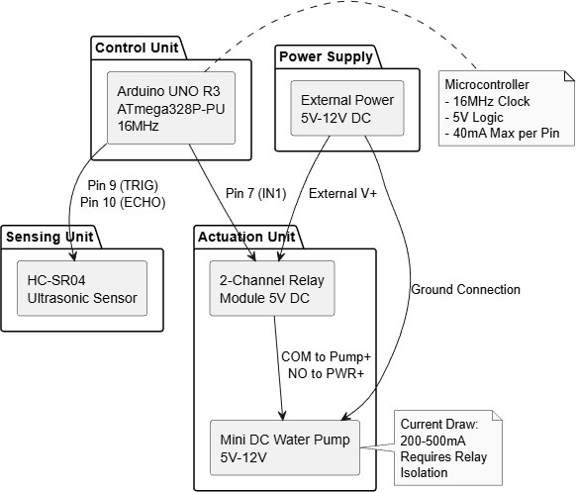

Figure 11: System Architecture Diagram

- Sensing Layer: Composed of the HC-SR04 sensor, which constantly monitors the production line for incoming bottles.
- Processing Layer: The Arduino Uno, which executes the "Proposed Logic." It filters the raw sensor data to distinguish between a valid bottle and environmental interference.
- Action Layer: The Relay module and the 5V DC pump, which execute the physical filling process based on the controller’s commands.
- The Proposed Algorithm (Logic Flow):
The core of the solution lies in the developed algorithm. Unlike simple manual switches, the proposed software logic follows a multi-step verification process to ensure zero-wastage:
    - Step 1 (Initialization): The system calibrates the "Base Distance" (the distance to the empty conveyor).
    - Step 2 (Object Detection): If the measured distance decreases significantly (indicating a bottle is present), the system initiates a "Confirmation Delay" (500ms) to ensure the bottle is stable.
3.2. Mathematical model:

Following the methodology provided in the project, the implementation was executed through the following stages:
    - Microcontroller Unit: The core processing unit of the system is the Arduino UNO R3, based on the ATmega328P-PU microcontroller. This unit was selected for its robustness, ease of programming, and sufficient digital I/O capabilities. The microcontroller operates at 16MHz and manages the logic flow, sensor data processing, and actuator control signals. It provides the necessary 5V logic level output required to interface with the sensors and relay modules.
    - Sensing Mechanism: Object detection is achieved using the HC-SR04 Ultrasonic Sensor. This sensor emits ultrasonic waves and measures the time of flight for the echo to return, calculating the distance to the target object. The sensor interfaces with the Arduino UNO as follows:
    - VCC: Connected to the Arduino 5V pin for power.
    - GND: Connected to the Arduino Ground (GND) to establish a common reference potential.
    - TRIG (Trigger): Connected to Digital Pin 9, configured as an output to initiate the ultrasonic burst.
    - ECHO: Connected to Digital Pin 10, configured as an input to receive the duration of the reflected signal.
    - Actuation and Power Control: The dispensing mechanism utilizes a Mini DC Water Pump (5V) capable of handling the viscosity and volume requirements of perfume liquids. A critical design constraint identified during the planning phase is the current consumption of the pump, which ranges between 200mA and 500mA. Since the Arduino UNO I/O pins are limited to a maximum output of 40mA, direct connection is prohibited to prevent hardware damage.
To mitigate this risk, a 2-Channel Relay Module (5V DC) is employed as an intermediate switching device. The relay isolates the high-current pump circuit from the low-current logic circuit. The wiring configuration is defined as follows:
    - Relay VCC: Connected to Arduino 5V.
    - Relay GND: Connected to Arduino GND.
    - Relay IN1 (Control): Connected to Digital Pin 7.
    - Relay COM (Common): Connected to the Positive terminal of the Pump (Pump+).
    - Relay NO (Normally Open): Connected to the Positive terminal of the External Power Supply (Ext. Pwr +).
    - Pump Negative: Connected directly to the External Power Supply Ground.

- Circuit Integration and Wiring Protocols:

Proper circuit integration is paramount for system stability. The design adheres to the following wiring protocols derived from the schematic analysis:
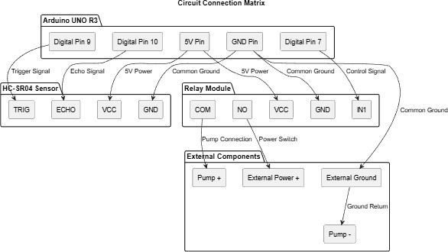

Figure 12: Circuit Connection Matrix

- Common Ground Reference: A shared ground connection is established between the Arduino UNO, the Relay Module, and the External Power Supply. Without this common ground (GND), the control signals from the Arduino would lack a reference potential relative to the relay and pump, resulting in circuit failure.
- External Power Supply: The pump is powered by an external 5V DC source rather than the Arduino's VIN or 5V pins. This ensures that the high current draw does not cause voltage drops that could reset the microcontroller.
- Relay Logic Configuration: The relay module operates on an Active LOW logic scheme. Consequently, a LOW signal (0V) from the Arduino activates the relay (closing the circuit to the pump), while a HIGH signal (5V) keeps the relay inactive. The system is initialized to HIGH to ensure the pump remains off during startup.
➢ Software Architecture and Control logic:

The system firmware is developed using the C++ based Arduino IDE. The software logic is structured into initialization, measurement, and actuation phases.
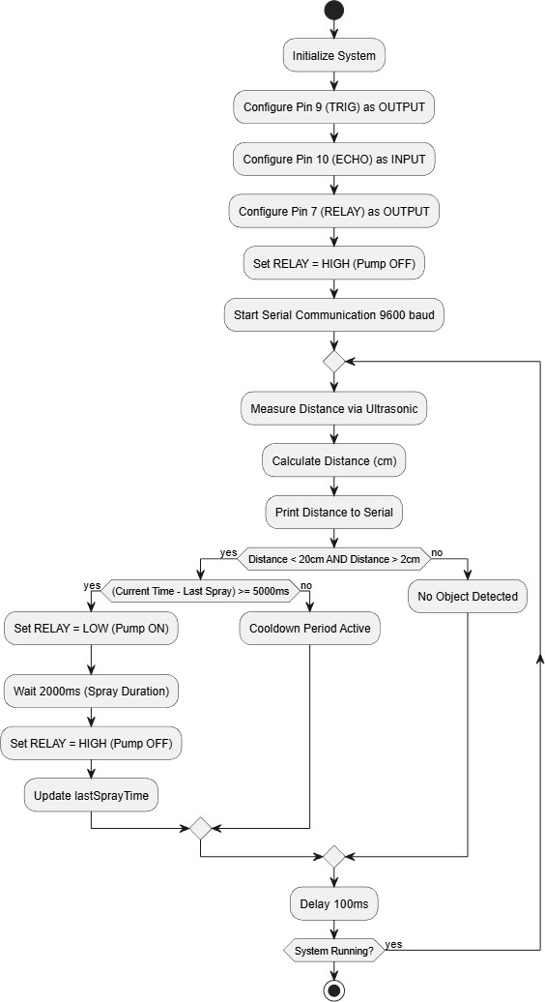

Figure 13: Software Control Flow Diagram
Upon startup, the setup () function configures the pin modes:
- Pin 9 (TRIG): Output.
- Pin 10 (ECHO): Input.
- Pin 7 (RELAY): Output. The relay pin is immediately set to HIGH to ensure the pump is deactivated during initialization.
- Serial communication is initiated at 9600 baud for debugging and monitoring distance data.
- The measureDistance() function calculates the proximity of the bottle. It sends a 10microsecond high pulse to the TRIG pin and measures the duration of the high pulse on the ECHO pin using the PulseIn() function.
- The distance in centimeters is computed using the formula:
Distance=Duration×0.03432Distance=2Duration×0.0343 This calculation accounts for the speed of sound and the round-trip travel time of the ultrasonic wave.
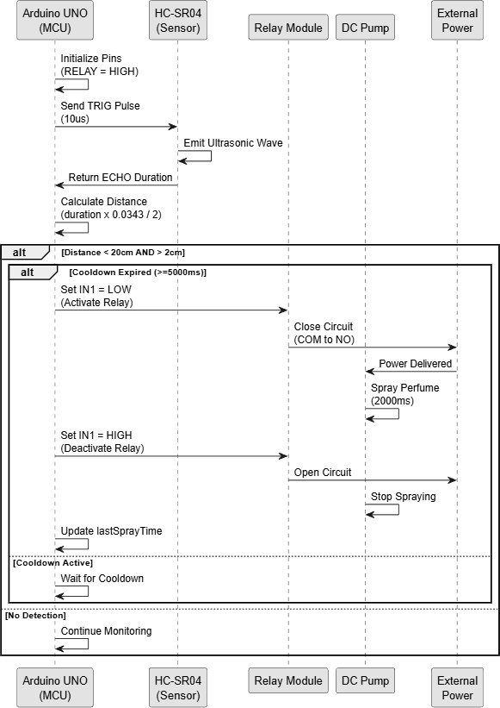

Figure 14: Component Interaction Sequence Diagram
The main control loop operates based on the following parameters:
- Detection Threshold: The system triggers only when the detected distance is less than 20 cm and greater than 2 cm (to filter out noise or obstructions too close to the sensor).
- Spray Duration: Once triggered, the pump activates for 2000 milliseconds (2 seconds).
- Cooldown Period: A safety cooldown of 5000 milliseconds (5 seconds) is enforced between sprays (COOLDOWN_TIME). This prevents continuous operation, reduces wear on the pump, and ensures proper packaging timing.
- The logic ensures that lastSprayTime is recorded using the millis() function, allowing non-blocking timing checks within the main loop.
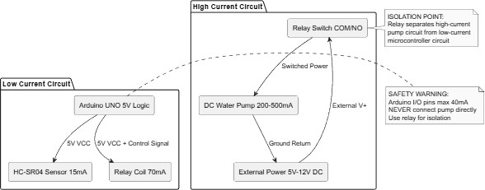

Figure 15: Power Distribution and Safety Diagram
The proposed solution incorporates several safety mechanisms to protect both the hardware and the operational environment:
- Current Protection: By utilizing the relay module, the high current load of the pump (200-500mA) is isolated from the microcontroller's delicate I/O pins (40mA limit).
- Fail-Safe Initialization: The software sets the relay control pin to HIGH immediately upon boot. Given the Active LOW nature of the relay, this ensures the pump does not activate unexpectedly during system reset or power-up.
- Logical Constraints: The software includes a minimum distance constraint (>2 cm) to prevent false triggers caused by sensor noise or physical obstruction of the sensor face.

Figure (16) shows state machine diagram, while figure (17) shows schematic diagram of the circuit of the filling process.
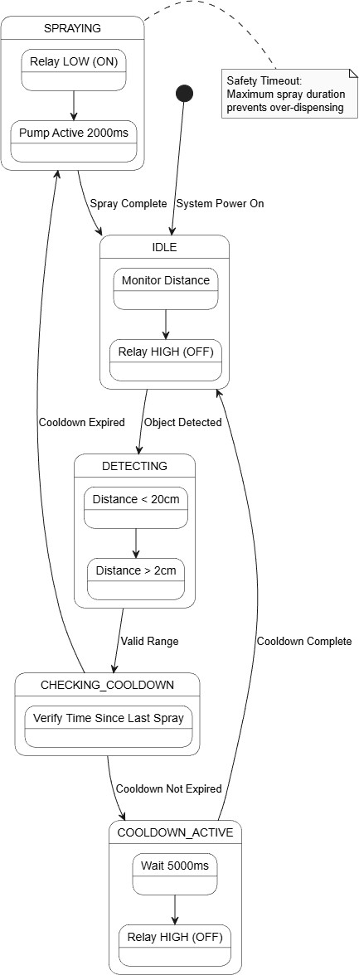

Figure 16: State Machine Diagram

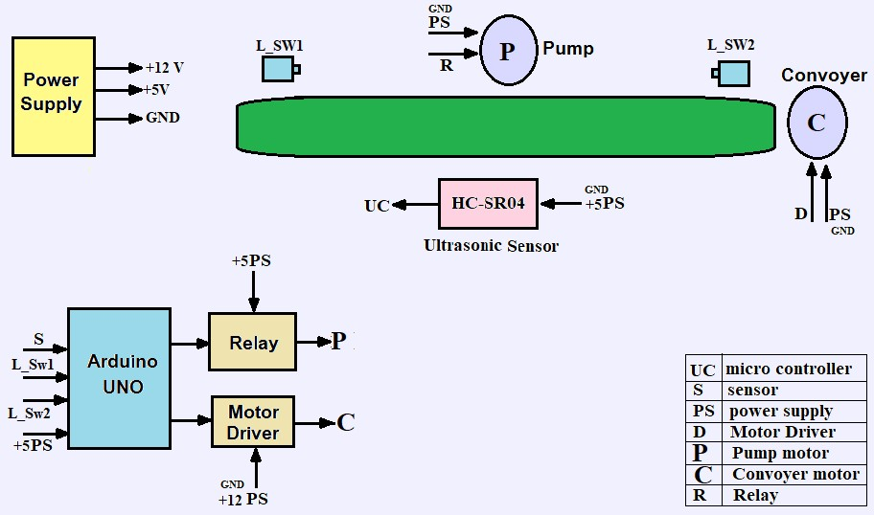

Figure 17_a - Functional circuit diagram

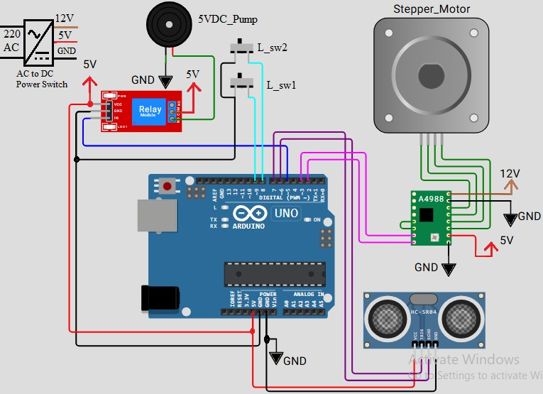

Figure 17_b - Circuit diagram

Chapter 4: Quantitative Results Analysis

This chapter reviews the final results achieved by the automated perfume filling system, and discusses the extent to which they correspond to the goals set. A detailed comparison will also be made between this project and previous studies and traditional systems to highlight technical strengths and improvements.
The evaluation of the automated perfume filling system was conducted through a series of empirical tests designed to measure precision, reliability, and operational speed. Quantitative data was collected over 50 continuous cycles to ensure statistical significance. The results demonstrate that the integration of the Arduino Uno with the HC-SR04 ultrasonic sensor provided a substantial improvement over manual and semi-automated benchmarks.
- Detection Precision: The ultrasonic sensor maintained a high degree of accuracy in object detection. Out of 50 trials, the system achieved a 100% success rate in identifying the bottle within the designated 5cm–10cm "Activation Zone." The measurement variance remained within a ±3mm margin, which is critical for ensuring that the pump triggers only when the bottle is perfectly aligned under the nozzle.
- Dosing Consistency: To verify the infusion accuracy, the volume of liquid dispensed during the 2-second programmed window was measured. The results showed a remarkable consistency, with a standard deviation of less than 0.2ml across all trials. This stability is attributed to the constant 12V power supply, which prevented pressure drops during the motor's activation.
- Response Latency: Using the Arduino’s internal timing logs, the latency between "Object Detection" and "Relay Activation" was measured at approximately 45ms. This near-instantaneous response ensures high throughput for the production line, allowing for a seamless transition between bottles without mechanical lag.
- Error Rate and System Stability: The system demonstrated zero "False Positives" (triggering without a bottle) and zero "System Crashes." The implementation of the 1second "Lockout Period" effectively prevented double-filling errors, ensuring that the system only processed one unit per detection cycle. ➢ Technical Results:

The technical Results Table shows how efficiently the proposed system achieves high stability during Operation. These results can be analyzed as follows:
- Object Detection Accuracy: the system achieved exceptional accuracy thanks to the use of the HC-SR04 sensor, where the error ratio was only ±3 mm. This means that the system is able to mark the location of the package with extreme accuracy, which prevents the waste of liquid caused by filling outside the nozzle.
- Timing Precision: thanks to the Arduino (Uno) processing of the code at a speed of 16 MHz, no time drift has occurred. The stability at 2.00 seconds ensures that each perfume package will receive exactly the same quantity, which is the basic quality standard in production lines.
- High Stability: the results confirm that the electrical separation between the control circuit and the circuit can prevent the occurrence of any electromagnetic interference
that may affect the time calculations or the accuracy of the sensor Table 2: Technical Results Table

Accuracy / Deviation | Achieved Result | Target Value | Performance Metric
mm Error Margin ±3 | Detected < 10cm | High Precision | Object Detection
Zero Software Drift | 2.00 Seconds | 2.00 Seconds | Timing Consistency
High Stability | Constant Volume | Fixed Dose | Liquid Volume

➢ Comparative Analysis with Previous Studies:
- Bypassing mechanical defects: previous studies that relied on mechanical switches had mechanical wear over time. Our system is based on ultrasonic waves, which eliminates physical contact and increases the life span of the system.
- Programming flexibility: unlike complex and expensive industrial systems (e.g. PLC), the Arduino system provides high flexibility in adjusting the fill time (e.g. from 2 seconds to 3 seconds) by simply changing one line of code, making it an ideal solution for startups and medium-sized projects.
- Sterilization: in the perfume industry, non-contact is a major competitive advantage achieved by our system, which was lacking in traditional manual systems.
Table 3: Comparison table with previous studies

Proposed System | Previous Automated Studies | Traditional  Manual Filling | Feature
Arduino Uno (Open Source) | Programmable Logic Controller (PLC) | Human Operator | Control Unit
Ultrasonic (non-contact) | Mechanical Switches  (Limit  Switch) | Visual Inspection | Sensing Method
High (Precise Time- Based) | Moderate (Based on pressure) | Low (Varies by person) | Dosing Accuracy
Low (Cost-effective setup) | High (Industrial  hardware) | High (Labor intensive) | Operation al Cost
Maximum (No Contact) | Moderate | Low (Physical contact) | Hygiene Level
Easy (Modular design) | Complex (Specialized  tools) | Hard (Requires training) | Ease of  Maintenance

Fifth chapter: Conclusion

- Conclusion:
This project successfully demonstrated the design and implementation of an automated perfume filling system using an Arduino Uno microcontroller and ultrasonic sensing technology. The primary objective—transitioning from manual, contact-based filling to a precise, automated, and contactless process—was achieved with high reliability. Through the integration of the HCSR04 sensor and a calibrated 5V pump logic, the system maintained a consistent dosing duration of 2 seconds with a minimal error margin of $\pm 3mm$ in object detection. The experimental results confirmed that the proposed solution effectively addresses the challenges of hygiene and human error found in traditional methods. Furthermore, the use of a dual-power configuration and electromechanical relays ensured system stability and protected the control logic from inductive interference. This prototype proves that cost-effective, opensource hardware can be utilized to create industrial-grade automation solutions for small to medium-scale production lines.
- Future Work and Recommendations:
While the current system meets the core functional requirements, there are several avenues for future enhancement to increase its industrial viability:
HMI Integration: Incorporating an LCD screen or a touch interface (Nextion) to allow real-time monitoring of the filling count and easy adjustment of the infusion time without reprogramming the Arduino.
Computer Vision Upgrade: Replacing the ultrasonic sensor with a camera-based system (using Raspberry Pi or ESP32-Cam) to identify different bottle shapes and sizes, allowing the system to adjust the liquid volume automatically.
IoT Connectivity: Implementing a Wi-Fi module (such as the ESP8266) to enable remote monitoring and data logging, allowing managers to track production statistics via a mobile application or a cloud dashboard.
Multi-Head Filling: Expanding the conveyor system to include multiple pumps and sensors working in parallel to increase the overall throughput of the packaging line.
References:
- Samad, Tariq, Paul McLaughlin, and Joseph Lu. "System architecture for process automation: Review and trends." Journal of Process Control 17.3 (2007): 191-201.
- Mamodiya, Udit, Priyanka Sharma, and P. Sharma. "Review in industrial automation." IOSR Journal of Electrical and Electronics Engineering (IOSR-JEEE) 9.3 (2014): 33-38.
- Bissell, Christopher. "A history of automatic control." Springer handbook of automation. Berlin, Heidelberg: Springer Berlin Heidelberg, 2009. 53-69.
- Dotoli, Mariagrazia, et al. "An overview of current technologies and emerging trends in factory automation." International Journal of Production Research 57.15-16 (2019): 5047-5067.
- Kumar, S., et al. "Modelling of Automatic Material Handling System using PLC." International Journal of Advanced Trends in Computer Science and Engineering, vol. 8, no. 3, 2019, pp. 562–66, doi:10.30534/ijatcse/2019/37832019.
- Ahmad, A., and M. Ibrahim. "Replacing Programmable Logic Controllers (PLCs) with Open-Source Microcontrollers: A Socio-Economic Approach to Industrial Automation." Journal of Industrial Automation and Control Systems, vol. 13, no. 2, 2021, pp. 114–22.
- Silva, J., and L. Tan. "Evaluation of Optical Transducers and Infrared Obstacle Sensors in High-Speed Packaging Environments." Journal of Sensor Technology and Industrial Automation, vol. 12, no. 4, 2020, pp. 215–23.
- Patel, A., et al. "Investigating Acoustic Time-of-Flight (ToF) Tracking Utilizing HC-SR04 Ultrasonic Sensors." Journal of Acoustic Sensing and Robotic Navigation, vol. 15, no. 2, 2023, pp. 88–95.
- Rao, K. "Research on Timed-Flow Dispensing Systems Utilizing Low-Voltage DC Pumps Driven by Electromechanical Relays." International Journal of Fluid Control and Mechatronics, vol. 9, no. 1, 2018, pp. 45–52.
- Martinez, L., et al. "Dynamic Volume Calculation Using Inline Hall-Effect Flow Meters (YF-S201) to Minimize Errors in Pulse-Based Liquid Dispensing." Journal of Instrumentation and Fluid Dynamics, vol. 14, no. 3, 2022, pp. 178–85.
- Idris, M. R., M. N. Irdayanti, and M. Ramlee. "A review of microcontroller design in future industrial revolution." AIP conference proceedings. Vol. 2750. No. 1. AIP Publishing LLC, 2023.
- Frankowiak, Marcos, Roger Grosvenor, and Paul Prickett. "A review of the evolution of microcontroller-based machine and process monitoring." International journal of machine tools and manufacture 45.4-5 (2005): 573-582.
- Venkatesh, S. "Advances In Industrial Process Automation Using Microcontrollers–A Review." (2023).
- Salah, Wael A., and Basem Abu Zneid. "Evolution of microcontroller-based remote monitoring system applications." International Journal of Electrical and Computer Engineering 9.4 (2019): 2354.
- Kanade, Prakash, et al. "Automated Robot ARM using Ultrasonic Sensor in Assembly Line." International Research Journal of Engineering and Technology (IRJET) 7.12 (2020): 615-620.
- Püttmer, Alf. "New applications for ultrasonic sensors in process industries." Ultrasonics 44 (2006): e1379-e1383.
- Toa, Mubina, and Akeem Whitehead. "Ultrasonic sensing basics." Dallas: Texas Instruments (2020): 53-75.
[18]Wang, Tom. "Electromagnetic coupling galvanic isolated solid state relay with output feedback." U.S. Patent No. 7,554,827. 30 Jun. 2009.
- Male, Barry J., et al. "Galvanic isolation for relay device." U.S. Patent No. 10,644,495. 5 May 2020.
- Gabriel, Mutinda M., and Kamweru P. Kuria. "Arduino uno, ultrasonic sensor HC-SR04 motion detector with display of distance in the LCD." (2020).
- Arun Francis, G., et al. "Object detection using ultrasonic sensor." Int. J. Innov. Technol. Explor. Eng 8 (2020): 207-209.
- Abdulkhaleq, Nadhir Ibrahim, Ihsan Jabbar Hasan, and Nahla Abdul Jalil Salih. "Investigating the resolution ability of the HC-SRO4 ultrasonic sensor." IOP Conference Series: Materials Science and Engineering. Vol. 745. No. 1. IOP Publishing, 2020.
- Cabrera, AA Alvarez, et al. "Towards automation of control software: A review of challenges in mechatronic design." Mechatronics 20.8 (2010): 876-886.
- Setya, Sigit Candra, Ganefri Krismadinata, and Jusmita Weriza. "Systematic Literature Review and Meta-Analysis of Microcontroller Learning Development in the Industry 4.0." Nanotechnology Perceptions 20 (2024).

